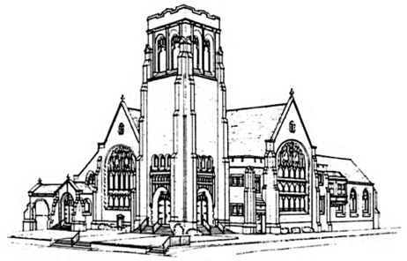
First Presbyterian Church

Fifth Sunday after Pentecost
July 2, 2023 at 10:00

THE CHURCH GATHERS

Handbell Chimes—The ringing of the chimes invites you to a time of Rest…Renewal…Hope

Prelude Rebecca Lentine, piano

Opening Sentences (Psalm 33, selected verses) Rejoice in the Lord, O you righteous. Praise befits the upright.
All: Sing to God a new song; play skillfully, with loud shouts.
One: The Lord brings the counsel of the nations to nothing; The Lord frustrates the plans of the peoples.
All: Happy is the nation whose God is the Lord, the people whom God has chosen as a heritage.
One: A king is not saved by his great army; a warrior is not delivered by his great strength.
All: The war horse is a vain hope for victory, and by its great might it cannot save.
One: Truly, God’s eye is on those who fear God, on those who hope in God’s steadfast love.
All: Our soul waits for the Lord; the Lord is our help and shield.
One: Our heart is glad in the Lord because we trust in God’s holy name.
All: Let your steadfast love, O Lord, be upon us, even as we hope in you.

* Hymn #338 (insert) “O Beautiful for Spacious Skies”

* An Invitation to Experience God's Grace (Hebrews 4:14-16)
One: Remember that our Lord Jesus can sympathize with us in our weaknesses, since in every respect he was tempted as we are, yet without sin. Let us then with boldness approach the throne of grace, that we may receive mercy and find grace to help in time of need.
All: We will confess our sins against God and our neighbor.

* Laying Down Our Burdens
All: God of Providence, your faithfulness is from everlasting to everlasting, but we fail to trust. You hold all creation in the palm of your hand, but we take our lives into our own hands more often than we would like to admit. When we trust ourselves more than your grace, forgive us. When we get caught up in our own strivings, relieve us. When we think the world rests on our shoulders, remind us. Call us back to your way. Teach us to turn our lives over to your gracious care. Amen.
* Silent Prayer
* Declaration of Forgiveness
One: The mercy of the Lord is from everlasting to everlasting. I declare to you, in the name of Jesus Christ, you are forgiven. May the God of mercy, who forgives you all your sins, strengthen you in all goodness, and by the power of the Holy Spirit keep you in eternal life.
All: Amen. Thanks be to God!

* We Celebrate God’s Forgiveness #579 Glory Be to the Father (Gloria Patri)

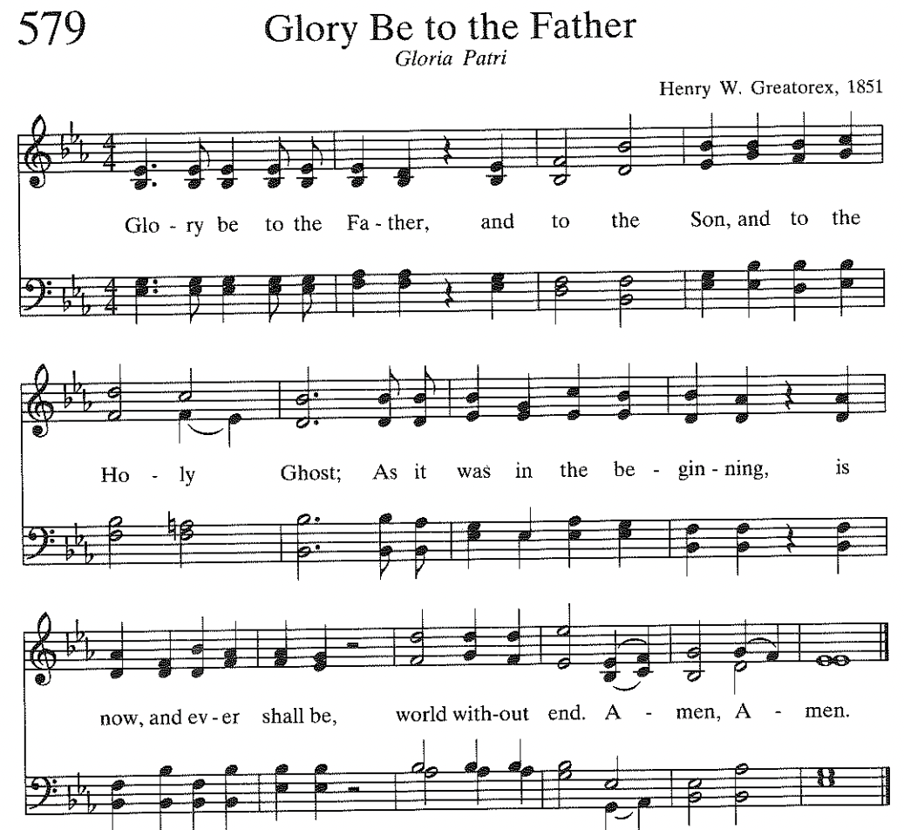

* Sharing the Peace of Christ
One: Since God has forgiven us in Christ, let us forgive one another. The peace of our Lord Jesus Christ be with you all.
All: And also with you.

Children’s Message

Celebrating the Life of the Congregation
(Please sign and pass the Friendship Registers and note those sitting around you)

GOD’S WORD PROCLAIMED

Prayer for Illumination
All: Gracious God, we do not live by bread alone, but by every word that comes from your mouth. Make us hungry for this heavenly food, that it may nourish us today in the ways of eternal life; through Jesus Christ, the bread of heaven. Amen.

Gospel Reading Genesis 22: 1-14
After these things God tested Abraham. He said to him, ‘Abraham!’ And he said, ‘Here I am.’ He said, ‘Take your son, your only son Isaac, whom you love, and go to the land of Moriah, and offer him there as a burnt-offering on one of the mountains that I shall show you.’ So Abraham rose early in the morning, saddled his donkey, and took two of his young men with him, and his son Isaac; he cut the wood for the burnt-offering, and set out and went to the place in the distance that God had shown him. On the third day Abraham looked up and saw the place far away. Then Abraham said to his young men, ‘Stay here with the donkey; the boy and I will go over there; we will worship, and then we will come back to you.’ Abraham took the wood of the burnt-offering and laid it on his son Isaac, and he himself carried the fire and the knife. So the two of them walked on together. Isaac said to his father Abraham, ‘Father!’ And he said, ‘Here I am, my son.’ He said, ‘The fire and the wood are here, but where is the lamb for a burnt-offering?’ Abraham said, ‘God himself will provide the lamb for a burnt-offering, my son.’ So the two of them walked on together.
When they came to the place that God had shown him, Abraham built an altar there and laid the wood in order. He bound his son Isaac, and laid him on the altar, on top of the wood. Then Abraham reached out his hand and took the knife to kill his son. But the angel of the Lord called to him from heaven, and said, ‘Abraham, Abraham!’ And he said, ‘Here I am.’ He said, ‘Do not lay your hand on the boy or do anything to him; for now I know that you fear God, since you have not withheld your son, your only son, from me.’ And Abraham looked up and saw a ram, caught in a thicket by its horns. Abraham went and took the ram and offered it up as a burnt-offering instead of his son. So Abraham called that place ‘The Lord will provide’; as it is said to this day, ‘On the mount of the Lord it shall be provided.’

One: This is the Word of the Lord.
All: Thanks be to God.

Sermon “Abraham’s Final Exam” Rev. Marvin Lindsay

* Affirmation of Faith — We Affirm our Faith from The Heidelberg Catechism
One: What is your only comfort in life and in death?
All: That I am not my own, but belong—body and soul, in life and in death—to my faithful Savior, Jesus Christ. He has fully paid for all my sins with his precious blood, and has set me free from the tyranny of the devil. He also watches over me in such a way that not a hair can fall from my head without the will of my Father in heaven; in fact, all things must work together for my salvation. Because I belong to him, Christ, by his Holy Spirit, assures me of eternal life and makes me wholeheartedly willing and ready from now on to live for him.

Practicing Abundant Generosity
https://onrealm.org/FirstPresbyteri11244/give/now

Offertory: “I Sought the Lord“, by Frederick Stevenson, Rich Kouhoupt, tenor
* Doxology #592 (below) “Praise God from Whom All Blessings Flow”
* Recommitting Our Lives to Service

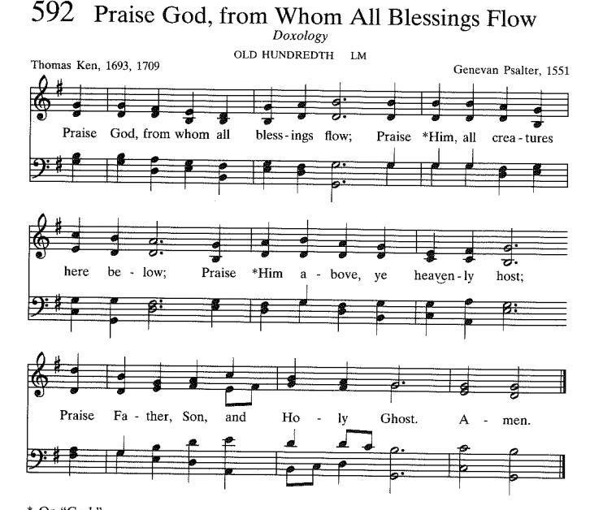

GIVE THANKS TO GOD

Prayers of the People and The Lord’s Prayer, p. 16, The Presbyterian Hymnal

Celebration of the Sacrament of the Lord’s Supper
Invitation
Prayer of Thanksgiving and Lord’s Prayer
One: The Lord be with you.
ALL: And also with you.
One: Lift up your hearts.
ALL: We lift them up to the Lord.
One: Let us give thanks to the Lord our God.
ALL: It is right to give our thanks and praise.

Everlasting God, we thank you for commanding light out of darkness, for dividing the waters into the sea and dry land, for creating the whole world and calling it good. You set us in this world to love and to serve you. And when we rebel against you, refusing to trust and obey you, you do not reject us. Instead, you claim us as your own and look upon us with Love.

Great and wonderful are your works, Lord God Almighty. Your ways are true and just. Living God, give us your Holy Spirit in the breaking of this bread and the sharing of this cup, that we may be drawn together as one, joined to Christ the Lord, receive new life, and remain his glad and faithful people until that day when we feast with Him in glory.

We are the Body of Christ. Through Christ, with Christ, in Christ, in the unity of the Holy Spirit, all glory and honor are yours, Almighty God, now and forever.

Grace-filled God, we humbly offer ourselves to you, praying now with the words you gave your disciples saying
[Lord's Prayer]

Words of Institution
The Lord Jesus on the night of his arrest and betrayal by those closest to him, took bread, and after giving thanks he broke it and said, "Take. Eat. This is my body, given for you. Do this, remembering me."

Then he took a cup and blessed it; giving it to them he said "This cup is the new covenant sealed in my blood, poured out for you and for many for the forgiveness of sins. Drink of it all of you, and remember me." Great is this mystery of faith:

ALL: Christ has died.
Christ is risen.
Christ will come again.

This is the body of Christ broken for you, the blood of Christ shed for you.
This is the body of Christ the Bread of Heaven; the blood of Christ the Cup of Salvation.
These are the gifts of God for the people of God.

ALL: Thanks be to God. Amen.

Distribution of the Elements
LEAVE TO SERVE

* Hymn #518 (insert) “Your Only Son”

* Charge and Benediction

Sending Music Rebecca Lentine, piano

Please use the Postlude time and music to reflect on today’s worship experience and how it will support you in the week to come.

* Please stand in body or spirit

Reprinted / Podcast / Streamed with Permission Under OneLicense #740987-A. All Rights Reserved.

WELCOME TO FIRST PRESBYTERIAN CHURCH! It is good to have you here in person or online. Please be in touch if you have news to share or would like more information or to talk to a pastor. Staff contact information is below. Read full announcements in our weekly email newsletter, available on the church website. Subscribe on the Contact Us tab.

THE NURSERY care is available in the Hospitality Center – across from Fellowship Hall.

AFTER-WORSHIP HOSPITALITY IS BACK! Linger a moment or two after the service to greet fellow worshippers. And please sign up with a friend or a group to host one Sunday by providing simple refreshments. There is a sign-up on the snack table or contact someone on the Hospitality Committee: jmfiorella@gmail.com, shoemakerjanet68@gmail.com, qlerch2@comcast.net, or phurd75@gmail.com,

PASTOR NIKKI LEADS SUMMER WORKSHOP SERIES BEGINS TODAY – This summer Pastor Nikki is offering three, one-hour workshops after Sunday worship in the Hospitality Center. Light snacks will be provided as well as ample time for questions and discussion!
Last Sunday June 25: ‘Prayer’
Together we’ll look at numerous resources on prayer: books, noteworthy authors, and famous (and not-so-famous) prayers. Along with suggestions for leading and sustaining prayer groups, we’ll explore what scholars, pastors, and Jesus say about prayer. And finally, we’ll learn more about creating our own prayers (and praying them aloud)!
Sunday July 16: ‘The Art and Skill of Connecting’
This workshop will provide the tools to connect with visitors and members of our church and will also equip any person to reach out to someone who is in need or struggling.
Sunday August 13: Gun Violence
The Presbyterian Outlook is dedicating its June issue to the topic of gun violence. The Christian Education and Justice and Advocacy committees invite you to join a discussion on August 13. Copies of the issue will be available.

PASTOR NIKKI’S BIBLE STUDY THURSDAYS @ 7 – Pastor Nikki is hosting a Bible Study via Zoom on the book of Genesis entitled “Genesis: Relational and Family Dynamics.” The reading schedule is linked on the Adult Ed page of the website. The Zoom link is https://us06web.zoom.us/j/81798184993, and we will also meet in person at pre-determined times. Please contact Pastor Nikki if you have questions and are interested, or join us on Zoom!

VBS REGISTRATION IS OPEN! This year’s VBS: Operation Restoration! invites kids to be Menders in God’s world. As they make connections between Bible stories and mending actions, they’ll discover simple ways to live out faith in daily life by exploring the daily themes of Feed, Heal, Forgive, Pray, and Rest. Dates are July 24-28, 2023. The cost is $25 per Mender, payable via Check (First Presbyterian of Haddonfield memo line: VBS), Venmo (@FPCHaddonfield), or through Realm (QR code links directly to Realm payment). Register Menders at https://bit.ly/466tnHi. Youth and adult volunteers register at https://bit.ly/3NqB9Et. See you in July!

Your Stephen Leaders will be offering Information Sessions about this important Ministry and what’s involved with becoming a Stephen Minister. You also will be able to hear from our Stephen Ministers about their experiences with the ministry to date. Interested in learning more? Attend one of the upcoming information sessions in the Hospitality Center: July 19, 7PM and July 20, 10AM Registration is preferred: stephenministry@haddonfieldpres.org
Questions? Contact a member of your Stephen Ministry Team.
Rev. Nikki Passante, Associate Pastor (npassante@haddonfieldpres.org)
Lisa Hurd, Stephen Leader (lhurd330@gmail.com)
Joyce Stout, Stephen Leader (joyce.stout@jefferson.edu)
Carol Carty, Stephen Leader (ccarty3@verizon.net)
Please join us!!
Want more information?
First Presbyterian Stephen Ministry website: http://www.haddonfieldpres.org/stephenministry
Stephen Ministry: https://www.stephenministries.org

WORSHIP ATTENDANCE 6/25/23: 94 in person and 11 online.

2023 CHURCH OFFERING UPDATE – Please note that target numbers on the right represent a 6-month goal, not the full year’s budget.
Received to date Six-month budget goal

Envelope Giving: $ 312,488.00 $ 285,135.00
Loose Offering: $ 6,193.00 $ 6,000.00
Per Capita: $ 8,777.00 $ 8,000.00

SCRIPTURE FOR SUNDAY, JULY 9: Genesis 24:34-38,42-49,58-67

The 4th of July is this week! Families and individuals concerned about the gun violence crisis in America are invited to march in Haddonfield's parade. You do not need to be a member of Moms Demand Action for Gun Sense in America to participate. Simply come to Chestnut Street at Kings Highway at 9:30am and look for the bright red MOMS banner. No signs required but if you do bring one, please remember this is a family friendly event.

PLASTICS FREE CHALLENGE in JULY! CAN YOU DO IT? The Earth is counting on you. How much plastic can you eliminate from your life during the first week of July?
(Not so) Fun Fact: Over nine million metric tons of plastic, including three million metric tons of microplastics, enter the environment globally every year! Plastic lasts hundreds to thousands of years and its toxic remains pose serious challenges.

OPENING THE SANCTUARY TO THE PUBLIC IN JULY – On July 8 and 9, during the Haddonfield Arts and Crafts Show, we would like to invite the public into the building. Please sign up to be a greeter for an hour on one of those days. All that’s required is your welcoming presence. Please use the new usher scheduling program: https://secure.rotundasoftware.com/29/web-terminal/login/haddonfieldpres? If you have questions, please contact Margot Dark: margotdark@msn.com. Brochures describing the stained-glass windows are available in the back of the Sanctuary.

Worship Activity Bags are now available for children attending worship in
Fellowship Hall this summer. The bags contain coloring sheets and crayons and may be taken home. Children are encouraged to draw on the bags themselves as well as the enclosed activity sheets.

CONGREGATIONAL PRAYER LIST

Please pray for the following individuals and situations throughout the week. If you would like to add a personal prayer request, please contact one of the pastors or our new Office Administrator, Olivia Willison. Requests will be revisited every 30 days.
- Pray for the people, government, and country of Ukraine as war continues.
- Pray for all our mission trip participants to return safely and pray for the lives they have touched this week!
- Keep Isabel Pross in your prayers as she undergoes cancer treatment (6/27-pastors)
- Pray for Francie’s mom who is has gone home to be on hospice (6/26-L. Sommers)
- Continued prayers for Todd (6/25-N. Passante)
- Continued prayers for Susan, who has been diagnosed with brain cancer and a mass in lungs. Help her to feel God’s presence and strength (6/24-C. Carty)
- Please pray for Renee. God knows the needs (6/22-pastors)
- Please pray for the Moody family of Pennsauken on the death of Dad Nate, who was a gasoline tanker driver in the I-95 crash. He leaves behind a wife and a 7 year old. The family is trying to make sense of this terrible tragedy (6/16- J. Wackes)
- Please pray for the family of Len Szyer of Philadelphia, the family patriarch who passed away following an illness (6/16-J. Wackes).
- Pray for healing for Antoine of Greenville, SC who is undergoing treatment for colon cancer in the ICU and for Terez and Wizard who are caring for him; may God give them strength and comfort (6/16-J. Wackes)
- Pray for Tony Gramkowski who is recovering from heart surgery and a stroke. He is in an ICU in Boston for his care (6/14 - MB Creamer)
- Please pray for Caroline Yount’s sister Michele as she recovers from back surgery (6/14-pastors).
- Please pray for Amy and Brad Strauss, that God would be present in their lives (6/13-pastors).
- Please pray for Mary Stringfellow who was hospitalized late last week after suffering a fall (6/5-pastors)

Church Staff

The Rev. Dr. Marvin Lindsay, Senior Pastor and Head of Staff – mlindsay@haddonfieldpres.org
The Rev. Nikki Perrine Passante, Associate Pastor – npassante@haddonfieldpres.org
Peter Leibensperger, Minister of Music – pleibensperger@haddonfieldpres.org
Lucas Brown, Principal Organist – lbrown@haddonfieldpres.org
Katie Beth McBurnie, Director of Children’s Ministry – kmcburnie@haddonfieldpres.org
Nancy Ruth Wainwright, Director of Children’s Choirs – nancyruthw@comcast.net
Marisa McGovern, Preschool Director – preschool@haddonfieldpres.org
Kris Bean, Business Manager – kbean@haddonfieldpres.org
Travis Bogetti, Building Manager – tbogetti@haddonfieldpres.org
Ed Hess, Community Caseworker – edwh517@aol.com
Olivia Willison — officeadmin@haddonfieldpres.org

20 Kings Highway E, Haddonfield, NJ 08033 ♦ www.haddonfieldpres.org ♦ (856) 429-1960

